

Fact sheet – August 2021

An outcomes-based approach to measuring migration – method overview
This fact sheet outlines information behind the classification model used to produce provisional estimates of migration in New Zealand.

Outcomes-based migration approach
Outcomes-based migration estimates are produced by measuring the time a traveller spends in/out of New Zealand after crossing the border. To do that, using travellers’ passport information, we identify their arrivals and departures, which we link together. The precise time spent in New Zealand or overseas is calculated from these linked records.
We then apply a 12/16-month rule to classify whether a border crossing is a migrant crossing (see Figure 1). For example, if a traveller who was not resident in New Zealand arrives, and they spend at least 12 of the next 16 months in New Zealand, they are deemed to be a migrant arrival and become a resident of New Zealand. Note that residency in this instance is a statistical concept, not a legal concept, and is entirely based on time spent in/out of New Zealand. Residency is also independent of citizenship, as both NZ and non-NZ citizens can be migrant arrivals and migrant departures.
Figure 1: The 12/16-month rule
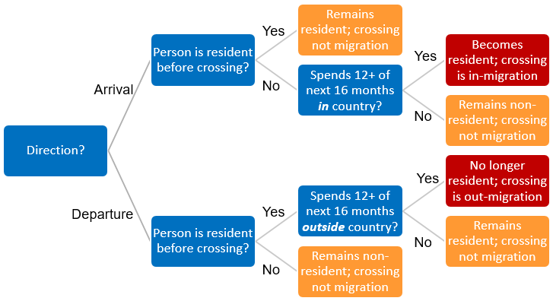

Estimating migration using a machine learning ‘predictive’ model
As seen in the example above, in general we must wait some time (in some cases up to 16 months) to definitively (deterministically) classify every border crossing as a migrant or otherwise. However, to provide more timely estimates of migration, we utilise a machine learning model that predicts what classification the 12/16-month rule gives a particular border crossing (if it is not already definitely known). These predictions are then used to produce ‘provisional’ migration estimates for the most recent 16 months.

Basics of the model
The model learns about the features of border crossings that make them more or less likely to be migrant crossings, by looking at millions of historical records. It then applies what it learns to the set of border crossings that are unknown (because not enough time has passed), at an individual crossing level, to estimate the probability that a particular arrival or departure is a migrant arrival or departure.

Learning to predict migration
The model looks at “features” in the historical border-crossing data:
- Features from the border crossing, such as the direction of crossing, and date of the crossing.
- Features of the 12/16-month rule, such as the amount of time in/out of country, the amount of time that has passed since the border crossing, the count of border crossings after the crossing to be classified, whether a traveller is still in the country, and their resident status before the border crossing.
- Features from the passport data, such as the age, sex, and citizenship of traveller, and the broad type of visa they hold.
Each of the records also has information on whether a particular crossing was a migrant crossing or not (the outcome). This allows it to establish links between different combinations of the features above, and the likelihood that a crossing is a migrant crossing. The model uses a technique called gradient boosting to do the learning. This is implemented using a well-established algorithm called “XGBoost”.
This process creates an ensemble of predictors that can be applied to border crossings where the outcome is unknown, based on the features in unknown border crossings. Using the established probabilities, we estimate the number of migrant crossings for a particular reference period, aggregated by different attributes, including age, sex, and country of previous residence.

Revising provisional estimates
The above process is run every month for any reference month that contains border crossings that are yet to be classified. In effect, any given reference month is estimated up to 16 times, as it takes 16 months to fully classify all border crossings deterministically. For example, migration estimates for the January 2020 month were first run and published in March 2020, and every month thereafter until 16 months had elapsed, with final estimates run and published in July 2021.
Because each subsequent model run happens with more time elapsed, the model has more information available to it each time. For example, if a non-resident traveller is still in the country, their “amount of time in the country” would increase, thus increasing the probability that they were a migrant arrival. Conversely, a non-resident traveller may have left in one of the proceeding months, in which case the model knows that they are no longer in the country, thus significantly reducing the probability that they were a migrant arrival.
The change in the probabilities results in the estimates changing. This leads to revisions each time the model is run, and we publish newly revised data each month. In general, as more time elapses, both the accuracy and precision of the estimate improves. After 16 months have elapsed, we have all the information we need to completely classify every border crossing, and the given reference month is “finalised”.

Model accuracy and its predictive power
Migration crossings are generally rare – roughly 1 in 50 crossings in 2019 was a migrant crossing (before COVID-19 related border closures) – so the overall predictive power of the model is low in early estimates of a given reference month and improves with time. The improvement happens for two reasons:
- As more time passes, non-migrant crossings in each reference month can be classified deterministically well before 16 months have passed. As border crossings get classified deterministically, the model no longer needs to account for them, making its job easier. For example, consider the arrival of a non-resident traveller that spent a month in New Zealand and departed:
  - Their departure can immediately be classified as a non-migrant departure. That’s because there are two possible outcomes for the traveller, depending on how their arrival ends up being classified. If the arrival is a non-migrant arrival, then the subsequent departure must also be non-migrant (effectively a departure of an overseas visitor). Alternatively, if the arrival is a migrant arrival (because of a later return to New Zealand), then the departure must also be non-migrant (effectively a departure of a NZ-resident traveller).
  - If the traveller has not returned within four months of their departure, their initial arrival cannot be a migrant crossing. This is because they have been away for more than 4 months since their arrival, so cannot possibly spend the required 12 months out of 16 in New Zealand. In this case, we no longer need to classify their arrival using the model.
- The information available to the model increases with time, meaning more accurate probabilities for a border crossing being a migrant crossing.

Comparisons to other models and development opportunities
In addition to using XGBoost, we also explored other modelling algorithms, such as random forests, general linear models, and some standard time series approaches. We found that the current model outperformed them. We were able to get smaller revisions month to month, using the current machine-learning model as a “seed” for aggregate time-series modelling, which essentially smooths the revisions. Time-series smoothing is less robust to shock changes, such as COVID-19, which the current model can handle.
We are currently investigating improvements to the uncertainty estimation of the model by looking at how it performs over a much longer historical series. To achieve this, we have created linked datasets stretching back to the year 2000, and the model’s performance is being evaluated against the known migration estimates for more than 200 months.
We will use this investigation to both assess any potential biases (particularly sensitivities to seasonal effects) and historical performance. This will then be used to develop uncertainty measures that better reflect the actual performance of the model historically, rather than the uncertainty in the modelled probabilities (which are the uncertainties currently published). This will give customers a better indication of how close a provisional estimate is likely to be to the final estimate.

Contact us:
If you’d like more information, have a question, or want to provide feedback, please email: demography@stats.govt.nz

